Smart Wash Laundry Management System

1. Overview
The Smart Wash Laundry Management System (SWLMS) is a comprehensive digital solution designed to automate and streamline laundry operations including pickup, washing, delivery, and order tracking. The system aims to enhance customer convenience and operational efficiency by providing a unified online platform accessible via web and mobile interfaces.

2. System Purpose
The primary goal of SWLMS is to eliminate manual processes and simplify the management of laundry services.
It allows:
- Customers to easily schedule pickups, track orders, and receive real-time updates.
- Staff to manage laundry tasks, pickups, and deliveries.
- Administrators to oversee all operations, users, and system data efficiently.

3. Technology Stack
Layer | Technology | Description
Frontend | ReactJS/React Native | Interactive and responsive user interface for web users
Backend | Fast API | Handles business logic and communication between UI and database
Database | MySQL | Stores structured data such as users, orders, addresses, and delivery details
API | FastAPI | Facilitates data exchange between the frontend, backend, and mobile app
Security | HTTP, JWT | Ensures secure authentication and data transfer

4. Core Modules
Module | Description
User Management | Registration, login, role assignment, and authentication
Address Management | Add, update, and delete customer addresses
Order Management | Create, update, and track laundry orders
Pickup & Delivery | Schedule and manage pickup and delivery services
Admin Dashboard | Monitor users, staff, and system activities

5. Architecture Overview
SWLMS follows a Three-Tier Architecture model:
- Presentation Layer – Web and mobile interfaces for user interaction.
- Application Layer – Django REST Framework managing requests, business logic, and data flow.
- Data Layer – MySQL database storing users, orders, items, and logistics data.
This structure ensures modularity, scalability, and maintainability across the system.

6. Security Implementation
- Encrypted passwords
- OTP verification for user validation and password resets.
- Role-Based Access Control (RBAC) for user, staff, and admin roles.
- Secure HTTPS communication to protect user data and transactions.

7. Key Benefits
- Automation of manual processes.
- Real-time tracking and transparent operations.
- Reduced human error and improved efficiency.
- Enhanced customer satisfaction and service reliability.
8. Flow Diagram (FD)
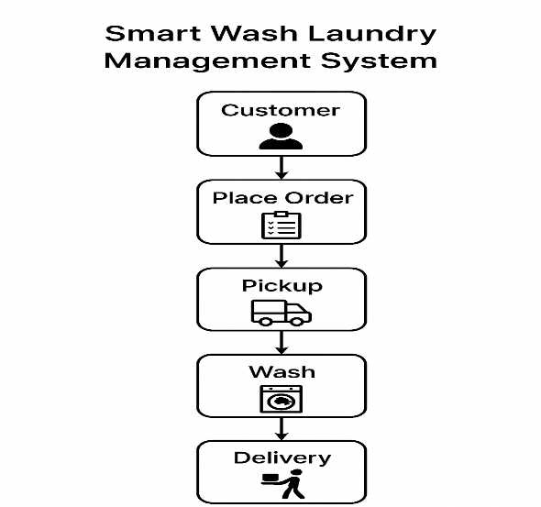
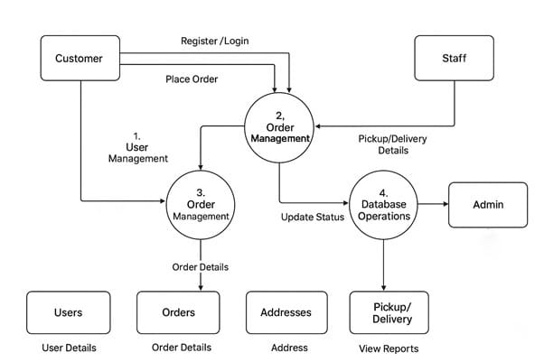

9. Future Enhancements
- AI-based analytics for order prediction and workload optimization.
- Online payment gateway integration
- Push notifications and customer feedback features.

10. Conclusion
The Smart Wash Laundry Management System is a modern, scalable, and secure platform that revolutionizes traditional laundry operations through digital automation.It delivers efficiency, transparency, and convenience to both service providers and customers, paving the way for future smart service innovations.

